Refer to <https://www.ibm.com/docs/en/planning-analytics/2.0.0?topic=icpame-install-planning-analytics-microsoft-excel-single-xll-add-in-versions-2065-later>

**Installing the Planning Analytics for Microsoft Excel add-in file as an add-in**

[Installing the Planning Analytics for Microsoft Excel add-in file as an add-in - IBM Documentation](https://www.ibm.com/docs/en/planning-analytics/2.0.0?topic=dupamesxaiv2l-installing-planning-analytics-microsoft-excel-add-in-file-as-add-in)

It’s an XLL file, no installation required

Please create the package to getting the add-in to automatically load. Once you have copied the file to a location on your pc, you add it to EXCEL

•         Open Excel

•         Click the Developer tab.

•         Click Excel Add-ins in the ribbon (not COM add-ins), just add-ins

•         Click Browse....

•         Find the Planning Analytics for Microsoft Excel add-in file you copied over earlier.

•         Click OK.

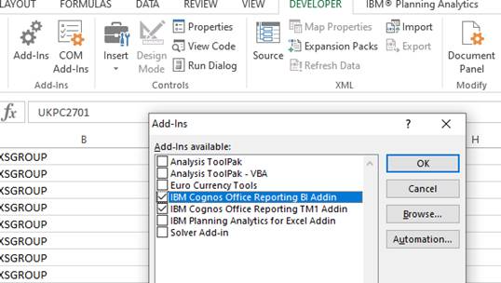

<https://support.microsoft.com/en-us/topic/excel-com-add-ins-and-automation-add-ins-91f5ff06-0c9c-b98e-06e9-3657964eec72>

The first issue is that the key varies from office installation to office installation, but it’s possible that I could pre select on that. I could sort out my Office 2013’s and Office 2016’s and have two separate install’s, if needed

The other, is that once selected there are keys created, but they are created under HKCU, which makes it a problem installing, as if I install as ADMIN it will create the key under the ADMIN HKCU hive, and not under the user hive

Excel 2013  
Key:            HKEY_CURRENT_USER\Software\Microsoft\Office\15.0\Excel\Options  
String:         OPENx  
Sample Value:   /A "ServerName.ClassName"

You’ll find the OPENx key created under options, but if another OPENx exists then it will create a key next number up, so I can’t just drop a key in called “OPEN” for fear for overwriting an existing entry if there is one

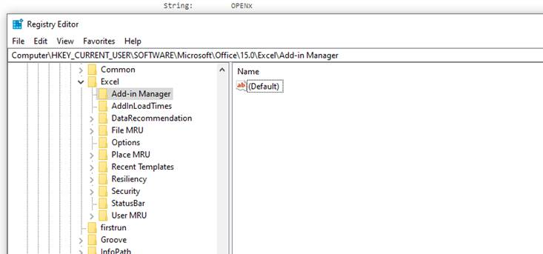

<https://bettersolutions.com/excel/add-ins/registry-keys.htm>

There is a VB script, but it failed on line 49 for me. This seems to do most of what I want, so long as I can get it loaded to the correct hive.